**Assignment – 7.3**

**Name:** Bhavaneesh.A

**Roll No:**  2403A52350

**Batch:** 13

**Task-1:** **syntax error.**

**Wrong Code:**

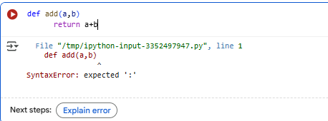

**Error Explanation:**

It looks like there is a Syntax Error in the code. In Python, you need to end a function definition line with a colon : .

**Corrected Code:**



**Task-2:** **Logical error.**

**Wrong Code:**

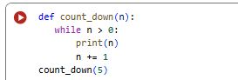

**Error Explanation:**

The error you're seeing, logical error, means that the execution of the code was stopped manually. Looking at the code, the count_down function has a while n > 0: loop, but inside the loop, n is increased with n += 1. This means that n will never become less than or equal to 0, resulting in an infinite loop.

**Corrected Code:**

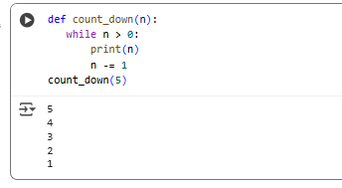

**Task-3:** **ZeroDivisionError.**

**Wrong Code:**

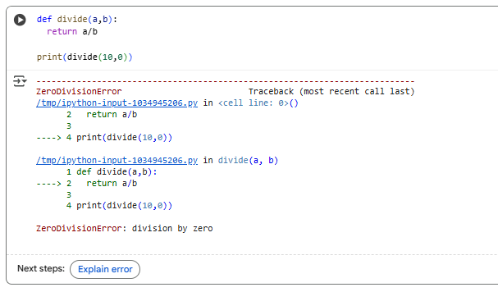

**Error Explanation:**

The error in the selected code is a ZeroDivisionError, which occurs because you are trying to divide by zero in the divide (10, 0) call. Division by zero is not allowed in Python.

**Corrected Code:**

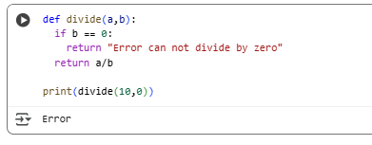

**Task-4:** class definition error

**Wrong Code:**

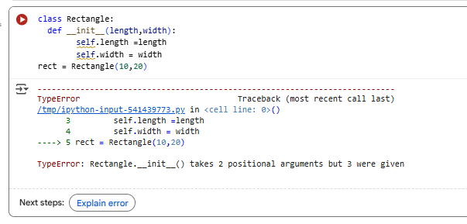

**Error Explanation:**

The error message TypeError: Rectangle.__init__() takes 2 positional arguments but 3 were given means that when you create an instance of the Rectangle class, the __init__ method is receiving more arguments than it's defined to accept.

In Python, the first parameter of instance methods (like __init__) is conventionally named self, and it refers to the instance of the object itself. So, even though you are passing 10 and 20 when creating rect, Python is also implicitly passing the rect object as the first argument.

To fix this, you need to include self as the first parameter in the __init__ method definition.

I have corrected the Rectangle class definition, and the code now runs without errors. You can now access the length and width attributes of the rect object, like rect.length and rect.width. Would you like to do that, or do you have another task for me?

**Corrected Code:**

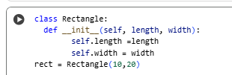

**Task-5 :** Index Error

**Wrong Code:**

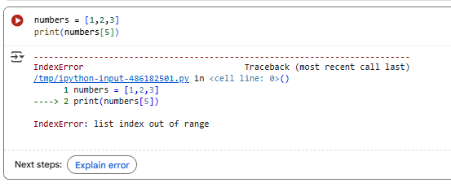

**Error Explanation:** The error in the selected code is an Index Error: list index out of range. This means you are trying to access an element in the numbers list using an index that does not exist in that list. The numbers list has elements at indices 0, 1, and 2, but you are trying to access the element at index 5.

**Corrected Code:**

